V. C. Summer Nuclear Project Review Committee
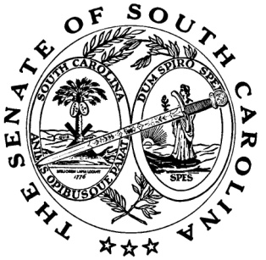
Senator Nikki Setzler, Co-Chairman Heather Anderson
Senator Shane A. Massey, Co-Chairman Staff Attorney, Judiciary and PURC
Senator Luke A. Rankin Sara Parrish
Senator Thomas C. Alexander Counsel to the Clerk
Senator C. Bradley Hutto Kate Wink
Senator Paul Campbell Sr. Budget Analyst, Finance Committee
Senator John L. Scott, Jr.
Senator Greg Gregory
Senator Sean Bennett
Senator Ronnie A. Sabb
Senator Mike Fanning
Senator Stephen Goldfinch
Post Office Box 142
Columbia, South Carolina 29202
(803) 212-6208

AGENDA

Tuesday, November 21, 2017
10:30 a.m.
Room 105, Gressette Building

I. Policy Discussion

